Curriculum Enhancement – Absence Reporting through SIMS Parent App
You can now report your child’s absence through the Parent SIMS App for the Curriculum Enhancement afternoon activities.
Please see the attached guide on how to do this and ensure it is submitted by 1pm on the day of the scheduled activity.
If you have not already downloaded the app, please click on the following link:
https://www.keaston.bham.sch.uk/page/?title=SIMS+Parent+App&pid=1295
Any issues with the App, please email: exams@keaston.bham.sch.uk
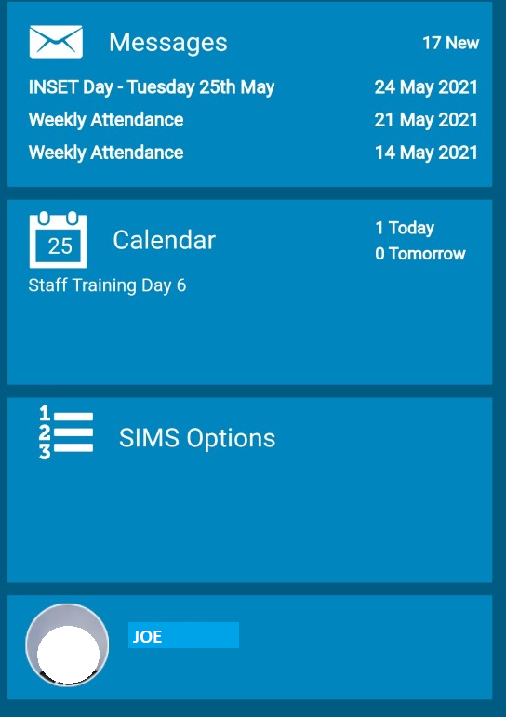
Step 1: Sign into the Parent SIMS App

Step 2:
Click on your son’s picture/name on the Home page:

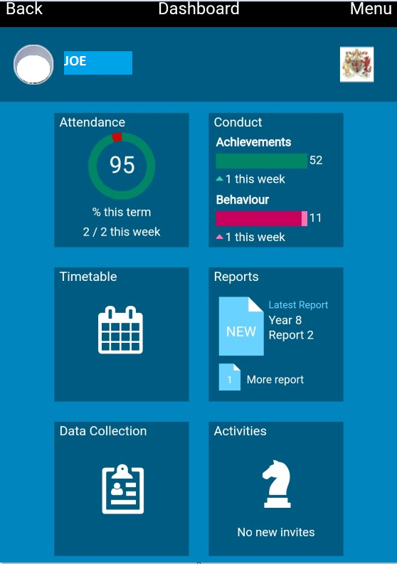

Step 3:
Click on the ‘Activities’ box
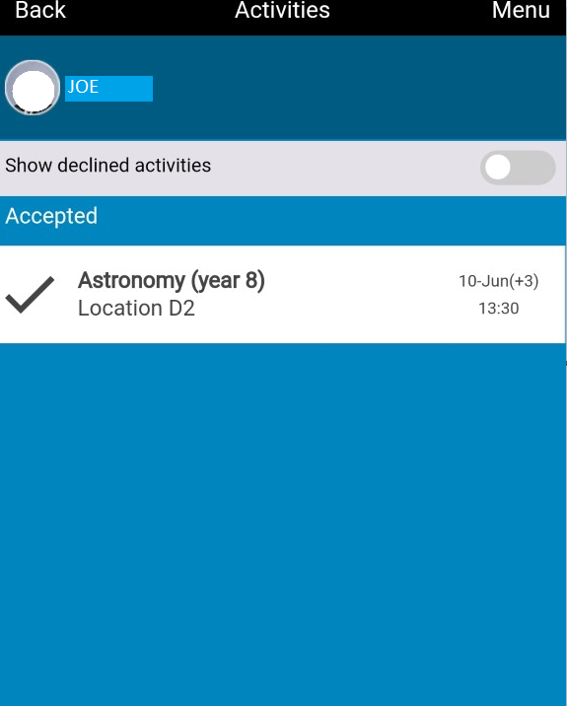

Step 4:

Click on the activity shown as accepted.

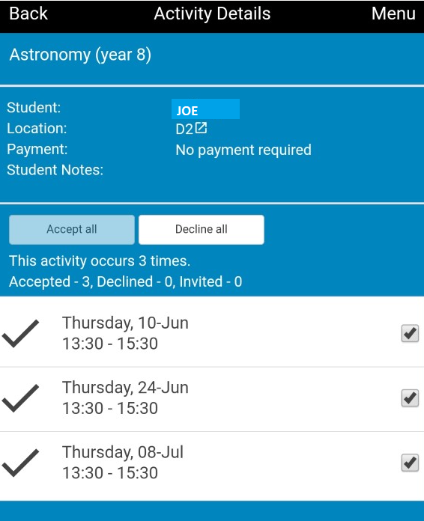

Step 4:

Step 5:

Untick the date(s) that your son will be absent and confirm.

