Guidance on acceptable school footwear
As a school we have always had high expectations of students’ uniform.
Our uniform policy specifies that all students must wear black school shoes only.
Any student arriving to school in incorrect footwear will be sanctioned in line with our behaviour policy. This may include: provision of a suitable pair of black shoes to wear, removal from lessons/break or being sent home to return in suitable footwear.
There is some guidance below to help you choose the correct footwear for your son. If you are in any doubt as to whether your child's shoes are acceptable please speak to a member of the Leadership team or your son’s Year Leader. Please note that the school retains the right to determine what is acceptable.
Please do not hesitate to contact the school for further advice if necessary.
Thank you for your support and attention.

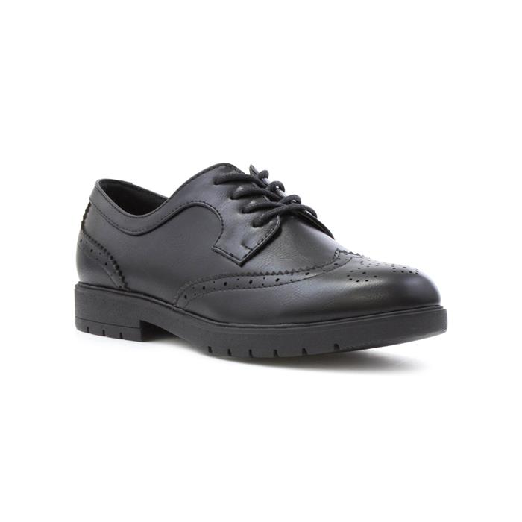
ACCEPTABLE FOOTWEAR – SAMPLE

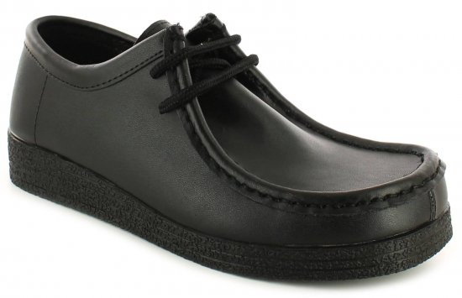

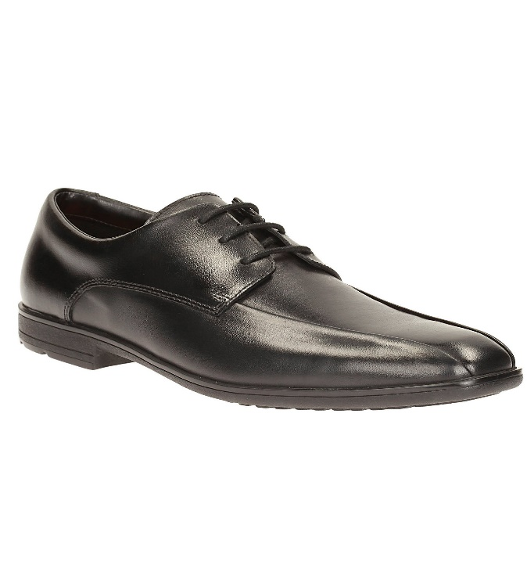

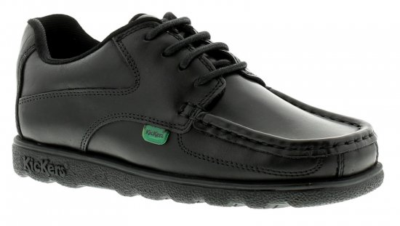

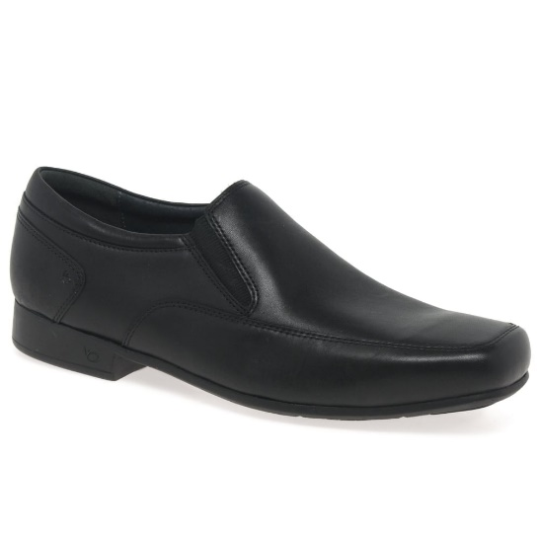
GUIDANCE:-
Black Leather
Laces or slip-on (no velcro)
Should be able to polish shoes!

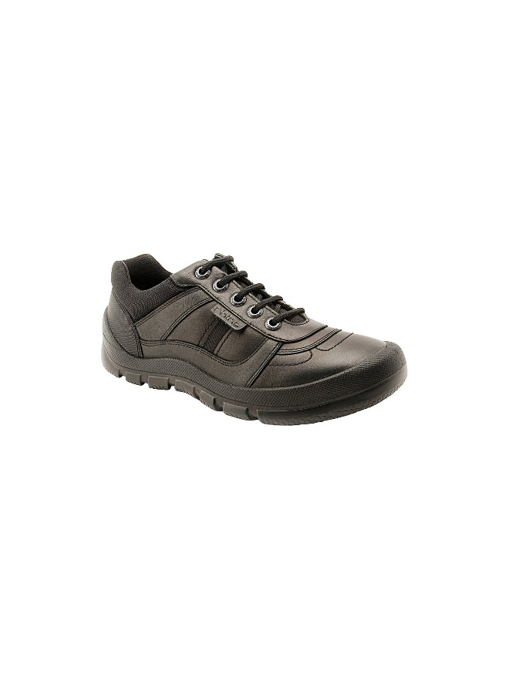
NON - ACCEPTABLE FOOTWEAR - SAMPLE

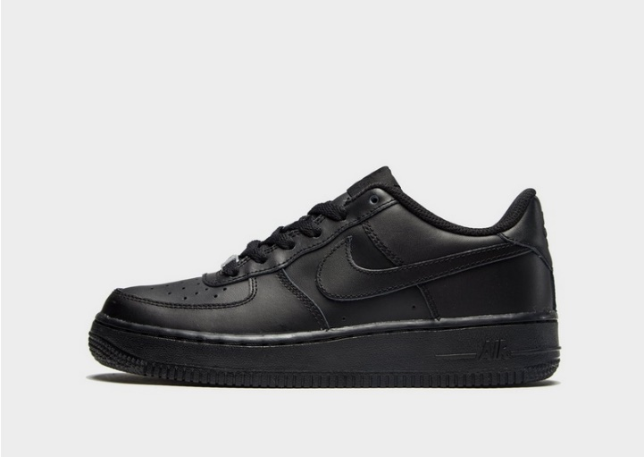

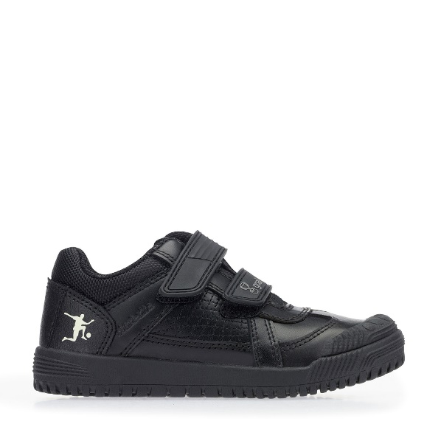
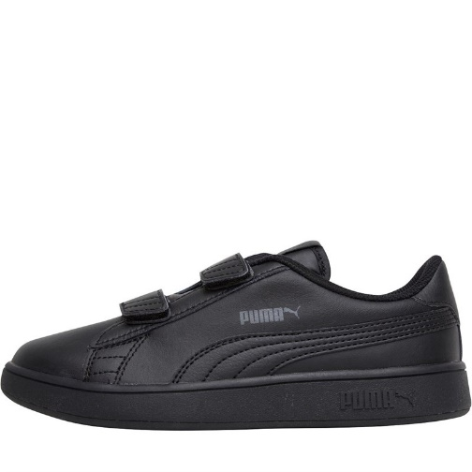

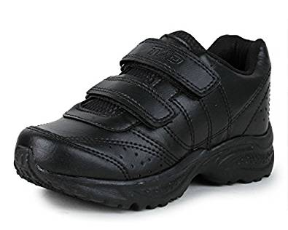
GUIDANCE:-
No boots above ankle height
No logos, coloured stitching
No sports brands – Nike, Reebok, Puma etc
No Velcro (laces or slip-ons only)
No trainers, trainer style shoes

